**ALAGAPPA COLLEGE OF TECHNOLOGY**

**ANNA UNIVERSITY-600025**

**Project type:**

Google Analytics: Embed a Google Analytics Code on your Website/ Blog

**Project name:**

Gen Z Automotiv**es**



**BRAND LOGO**

**Category:**

Automobile Brand

**Department:**

B.Tech – Food Technology

**Team Details:**

|  |  |  |
| --- | --- | --- |
| Name | Registration number | Naanmudhalvan Id |
| Abilash E | 2020304001 | 39D97F0F05C3C7D904F444FEBD1F39E6 |
| Absara M | 2020304002 | 68677576C633D48B02E4ADFE790093F5 |
| Dhinesh S | 2020304006 | CBB6F778287E09BB6314A3CDB29AC0E2 |
| Niranjani M | 2020304014 | B62C7E518311BA8A4914E26F7A975F79 |

Preethi L 2020304016 4497EC4A9D2F9B5BD7E41B14021C27F0

--------------------------------------------------------------

**Brand Name:** Gen Z Automotives

**Blog Name & Link**: Gen Z Automotives - https://genzautomotives.blogspot.com/2023/10/driving-forward-future-of-automobile_25.html

**Category:** Automobile Brand

**Target Audience:** General Public

**Email :** [genzautomotives@gmail.com](mailto:genzautomotives@gmail.com)

**File Upload** - Google Analytics Tracking Code : **G-45D3BBNFWQ**

Google Analytics: Embed a Google Analytics Code on your Blog

**Aim :**

To Embed a Google Analytics Code on your Blog.

**Overview :**

We created a blog based on our brand and created a google analytics code using the blog link and finally embedded the code on the blog.

**Purpose :**

Google Analytics is used to track website activity such as session duration, pages per session and the bounce rate of individuals using the site, along with the information on the source of the traffic. On a general note, Google Analytics is a web analytics service that provides statistics and basic analytical tools for search engine optimization (SEO) and marketing purposes.

**Procedure:**

1. Create an Google Account - [genzautomotives@gmail.com](mailto:genzautomotives@gmail.com)

2. Create New blogger account - https://genzautomotives.blogspot.com

3. Post the blog - <https://genzautomotives.blogspot.com/2023/10/driving-forward-future-of-> automobile_25.html

4. Create Google analytics Id - **G-45D3BBNFWQ**

5. Insert Google Analytics Code in blog

6. Make report (word documentation)

7. Upload in GitHub

**Result :**

Created the Google Analytics code and successfully embedded it in the blog

**Map:**

**Creating a brand logo –**

Choose logo template and edit the logo in canva using the brand name

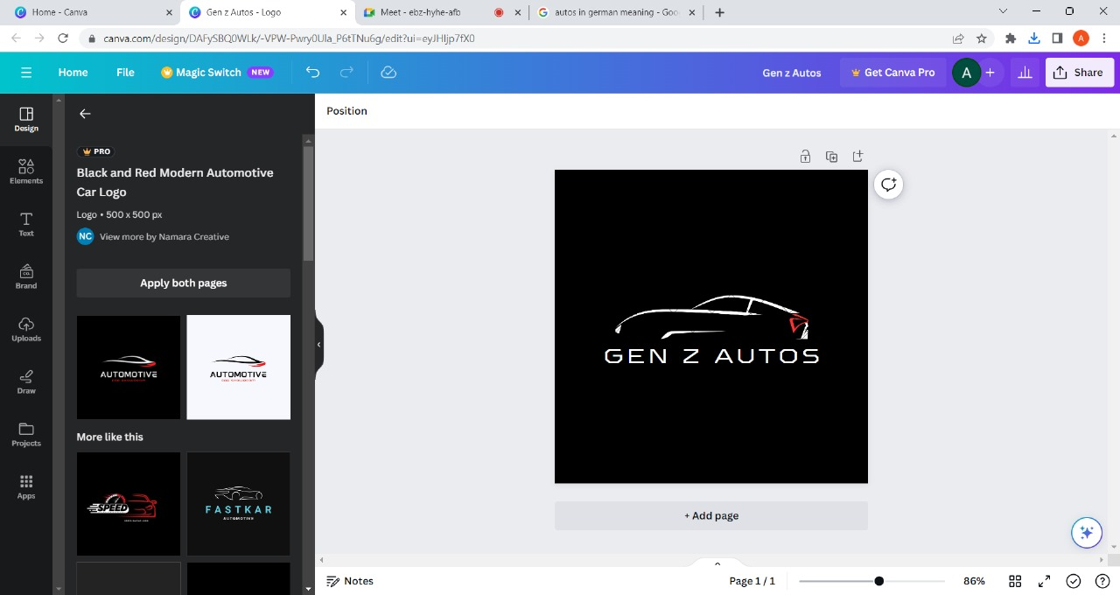



**Creating a Blog –**

**STEP 1:**

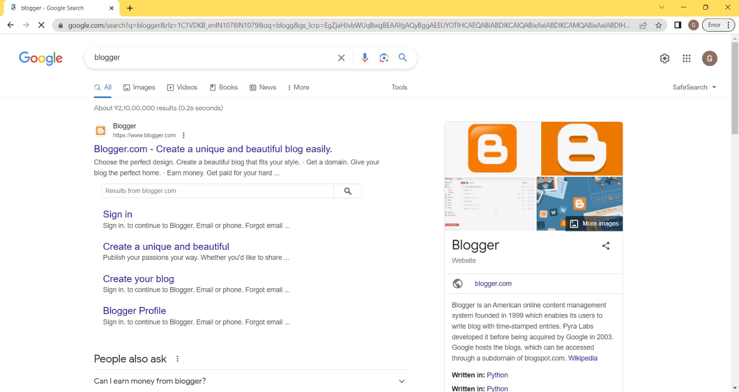

**STEP 2:**



After creating a blogger account, click on create post.

Post the content and give appropriate heading

Publish the post and share the link or have it copied. ( Clear description provided in recorded video - <https://drive.google.com/drive/folders/1-7AfPARFi6yYfwlC2AqSYShUvwKNFN-E> )

**Creating google analytics code and embedding it in the blog :**

**STEP 1:**



**STEP 2 :**



**STEP 3:**



**STEP 4:**

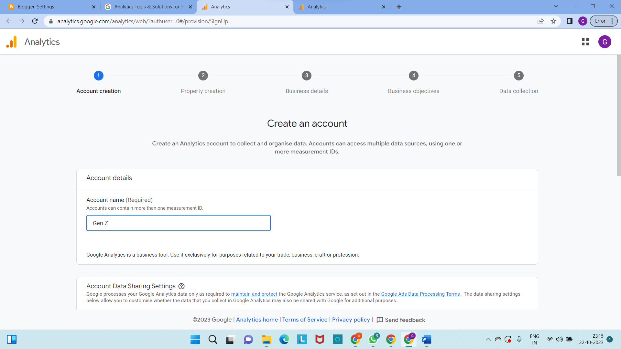

**STEP 5:**

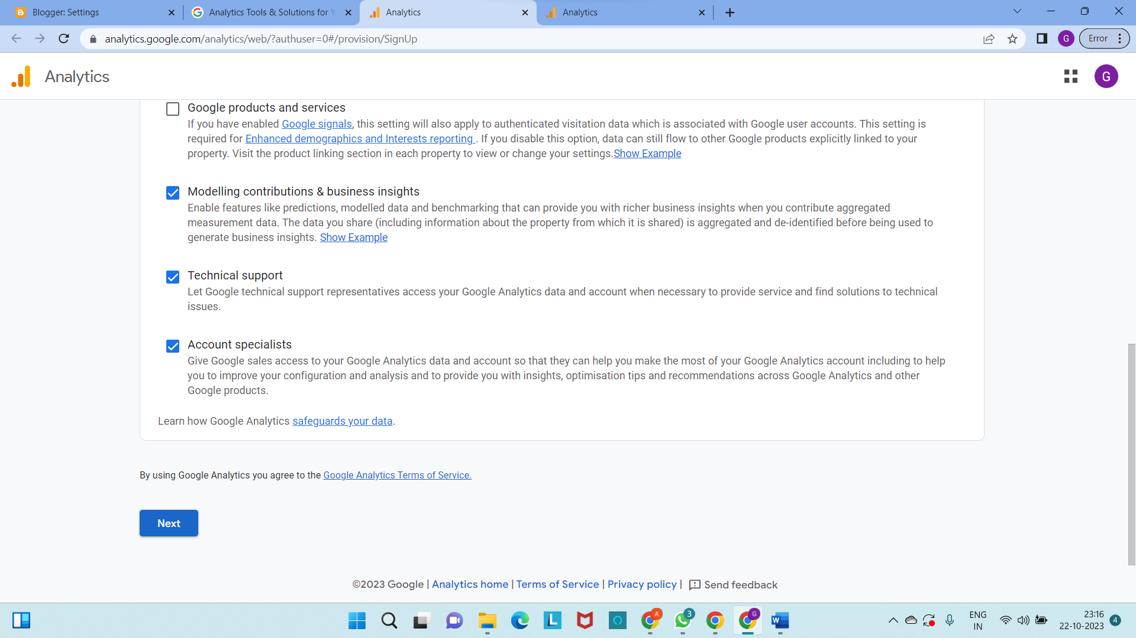

**STEP 6:**

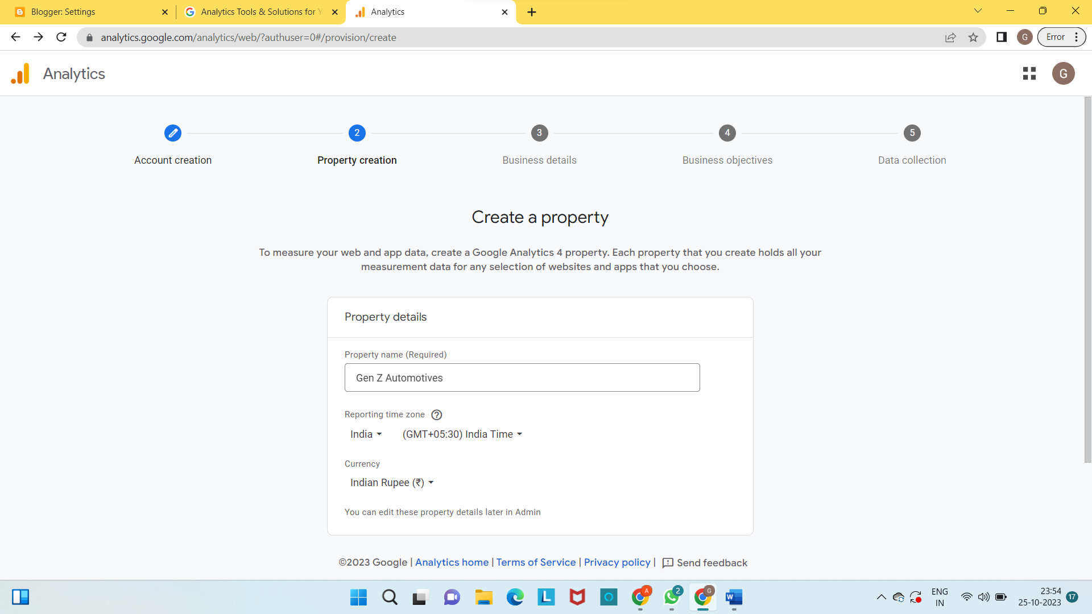

**STEP 7:**

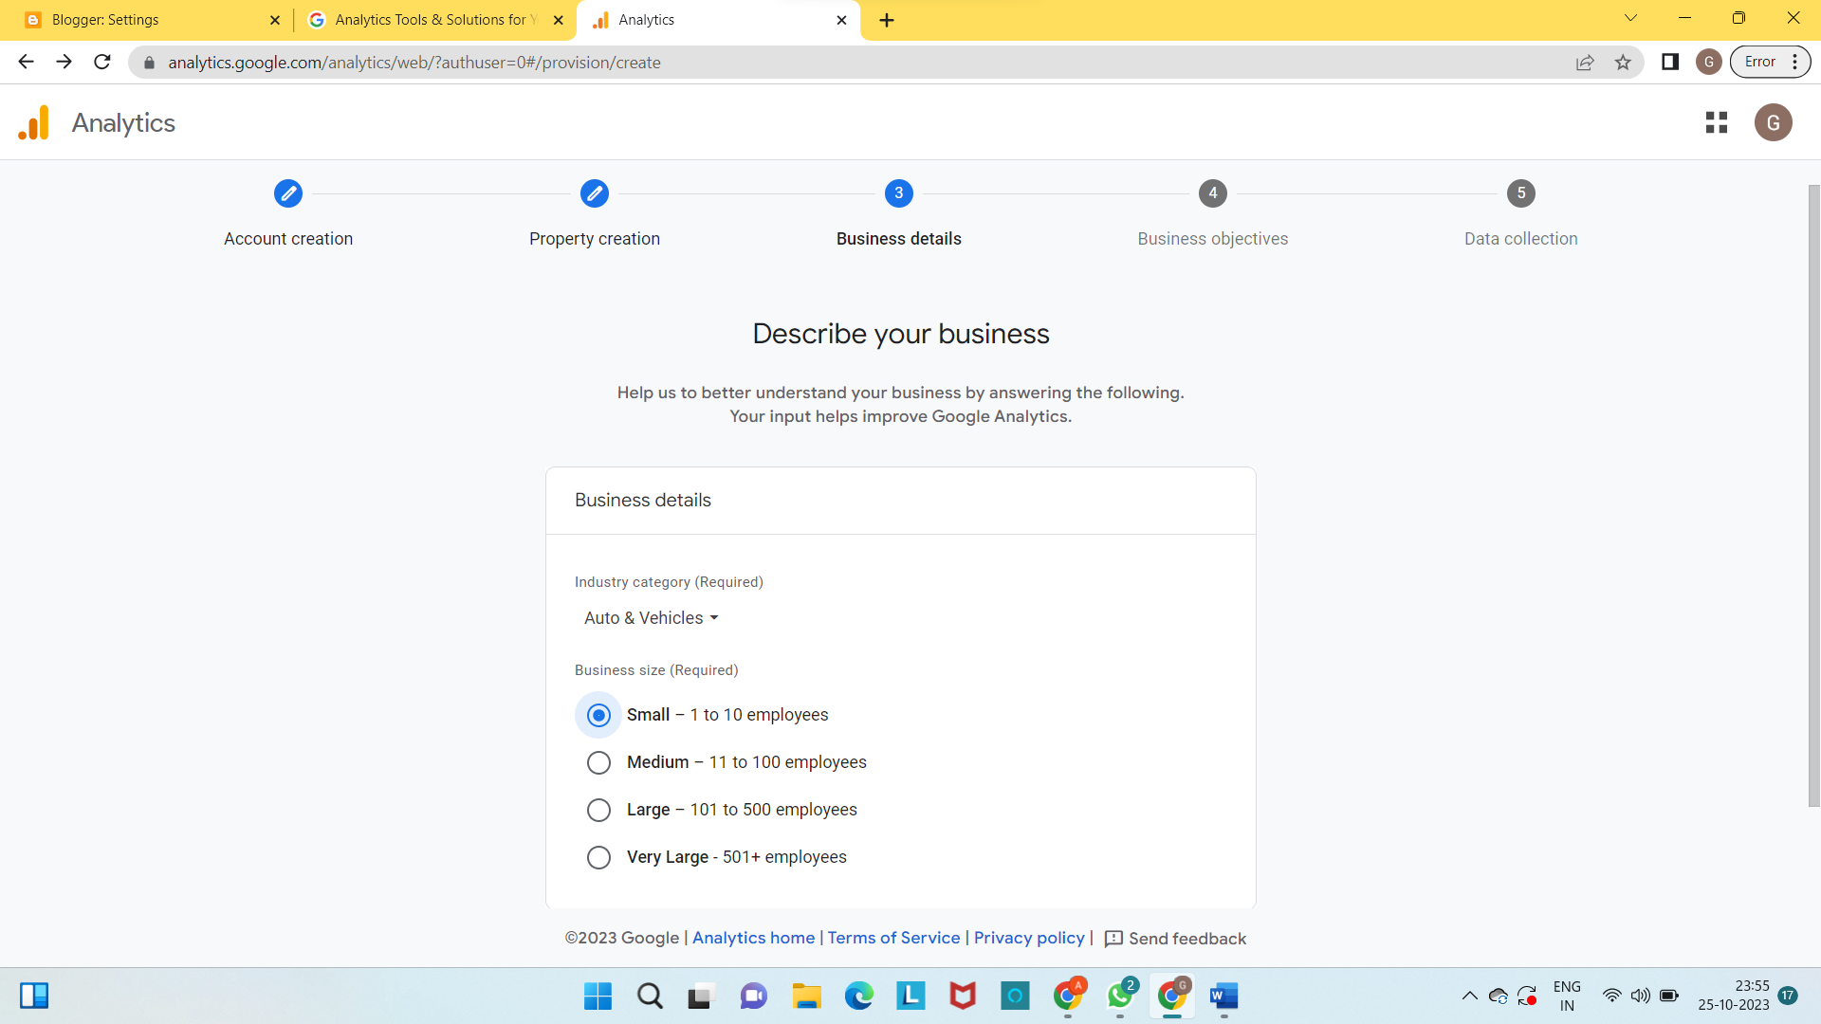

**STEP 8:**

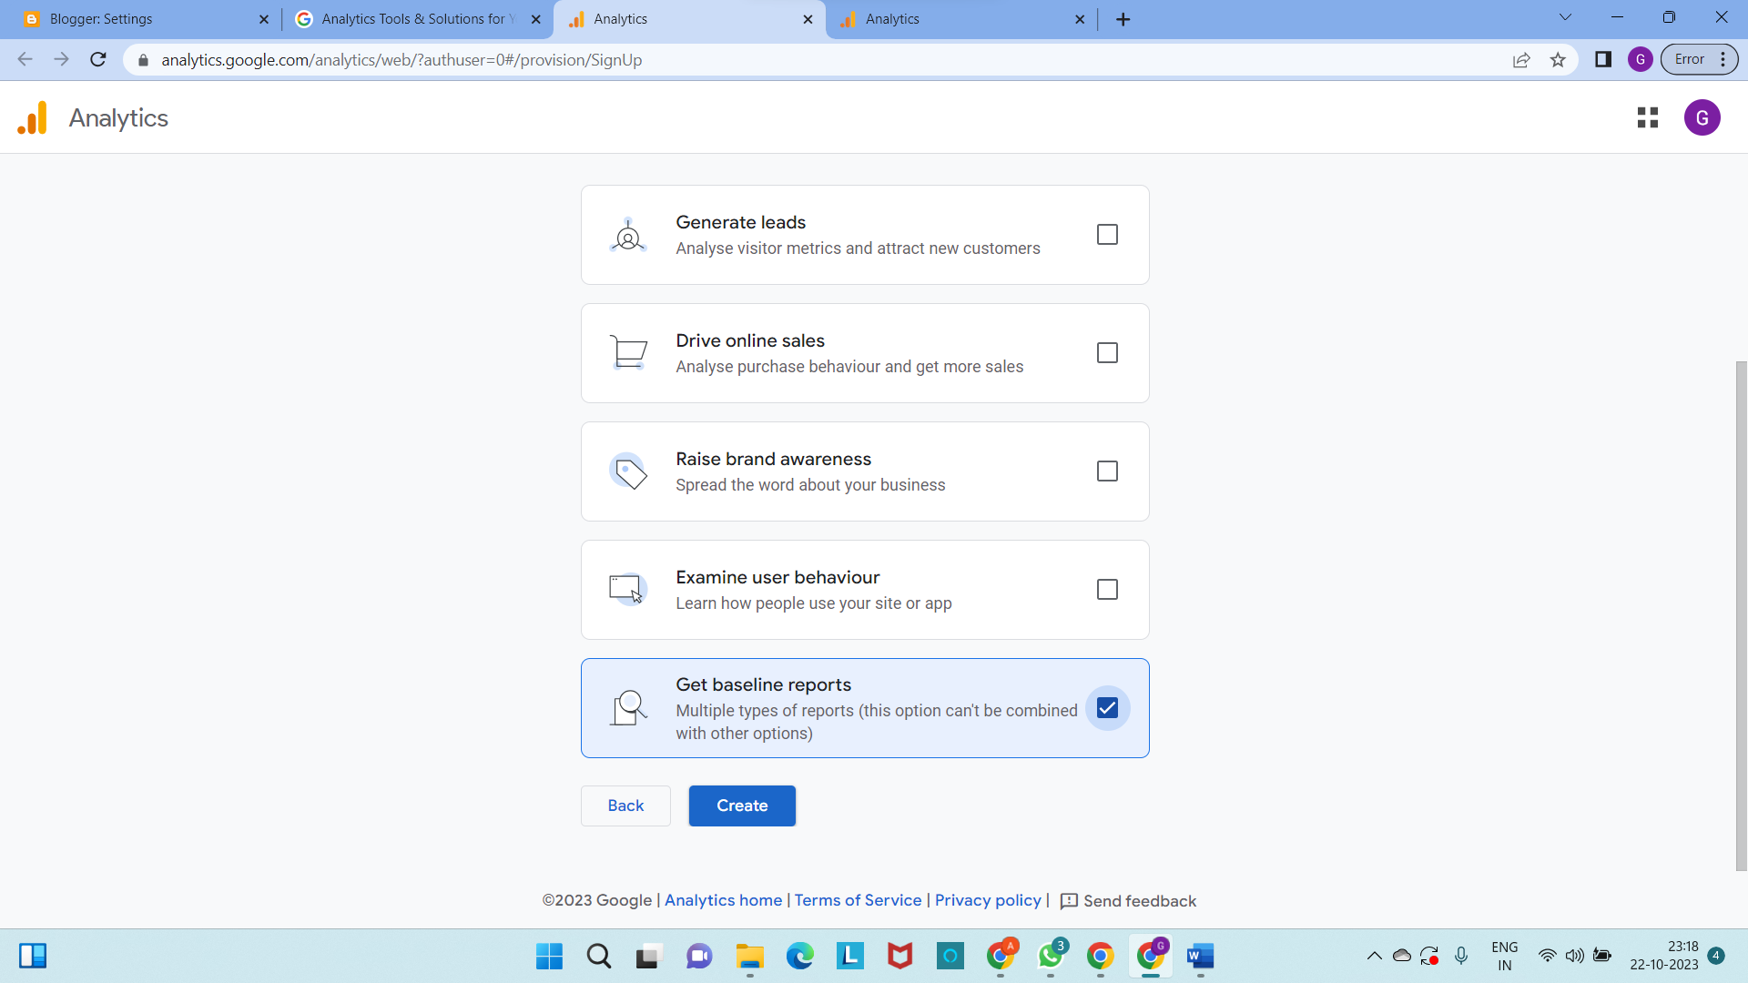

**STEP 9:**

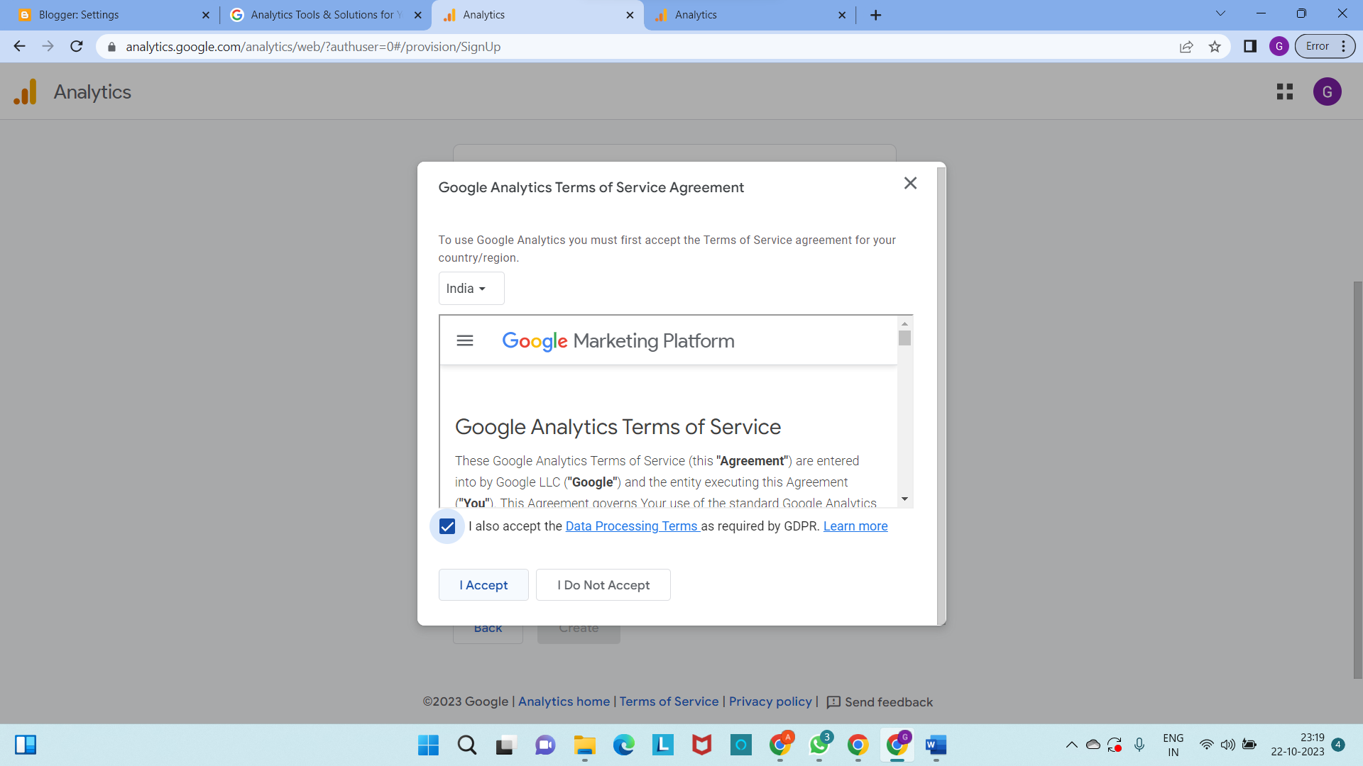

**STEP 10 :**

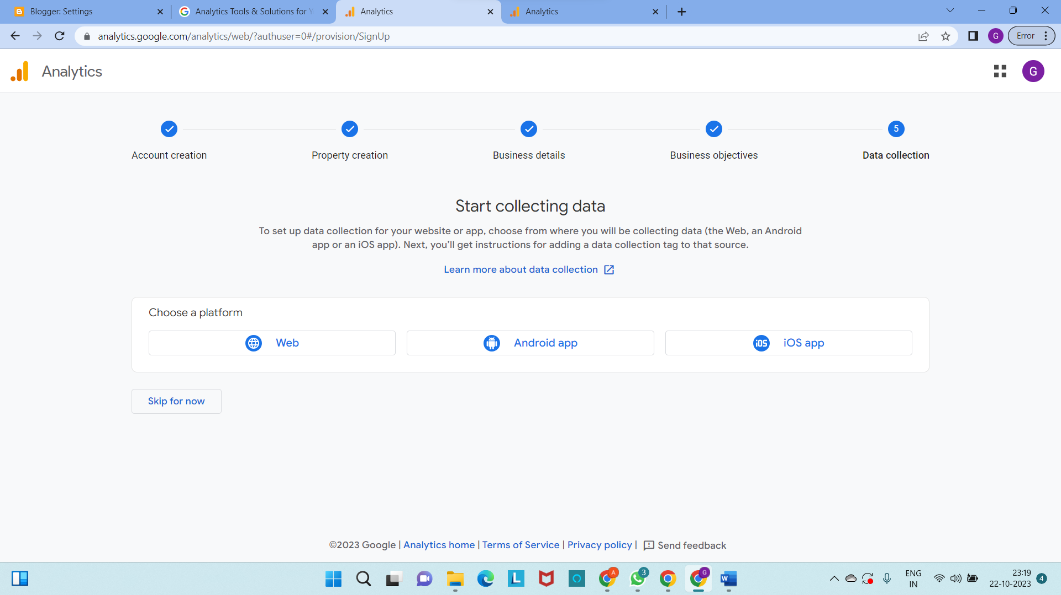

**STEP 11:**

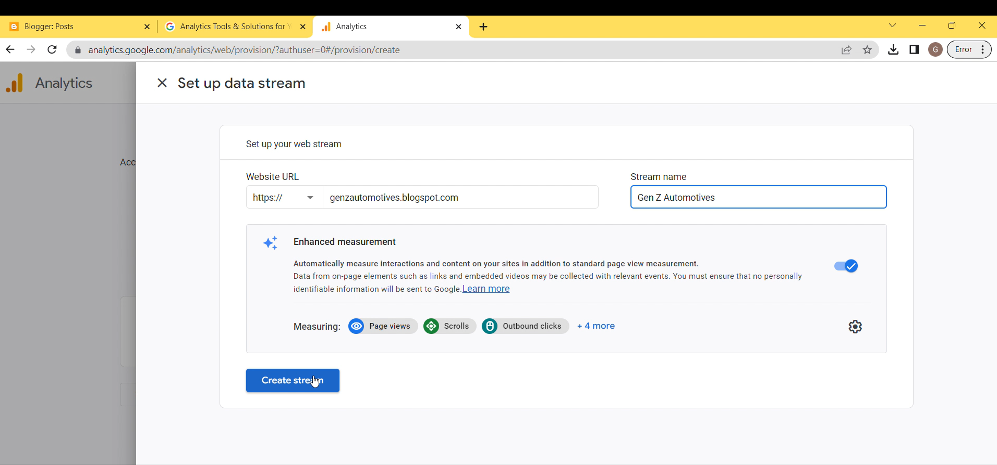

**STEP 12:**

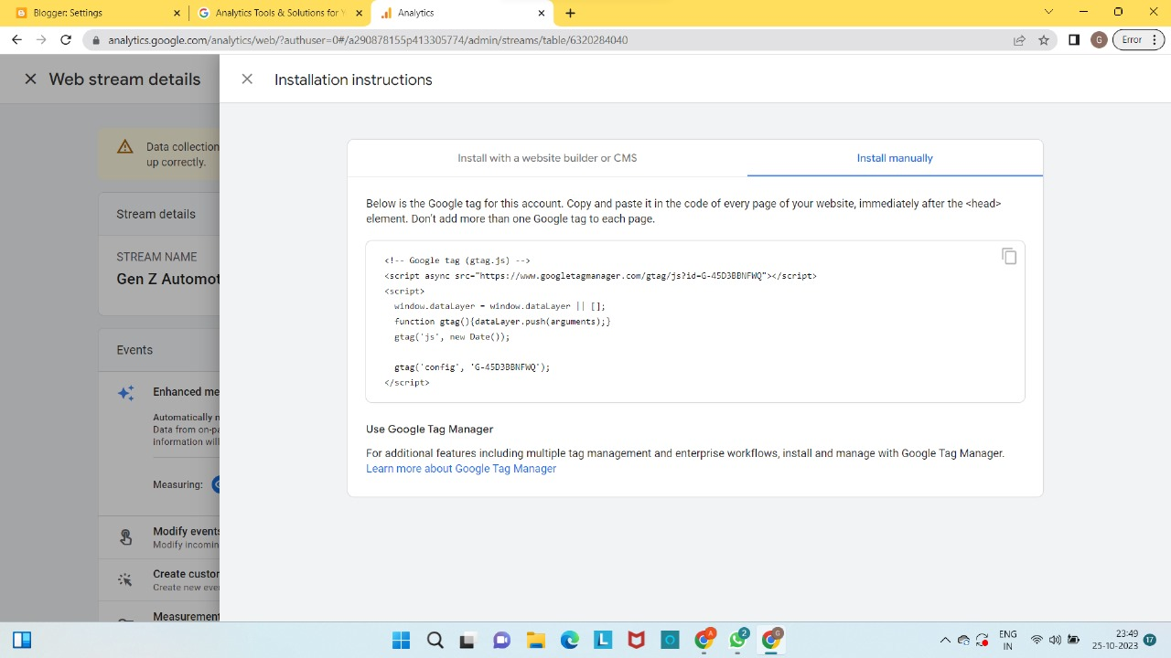

<!-- Google tag (gtag.js) -->

<script async src="https://www.googletagmanager.com/gtag/js?id=G-45D3BBNFWQ"></script>

<script>

window.dataLayer = window.dataLayer || [];

function gtag(){dataLayer.push(arguments);}

gtag('js', new Date());

gtag('config', 'G-45D3BBNFWQ');

</script>

**STEP 13:**

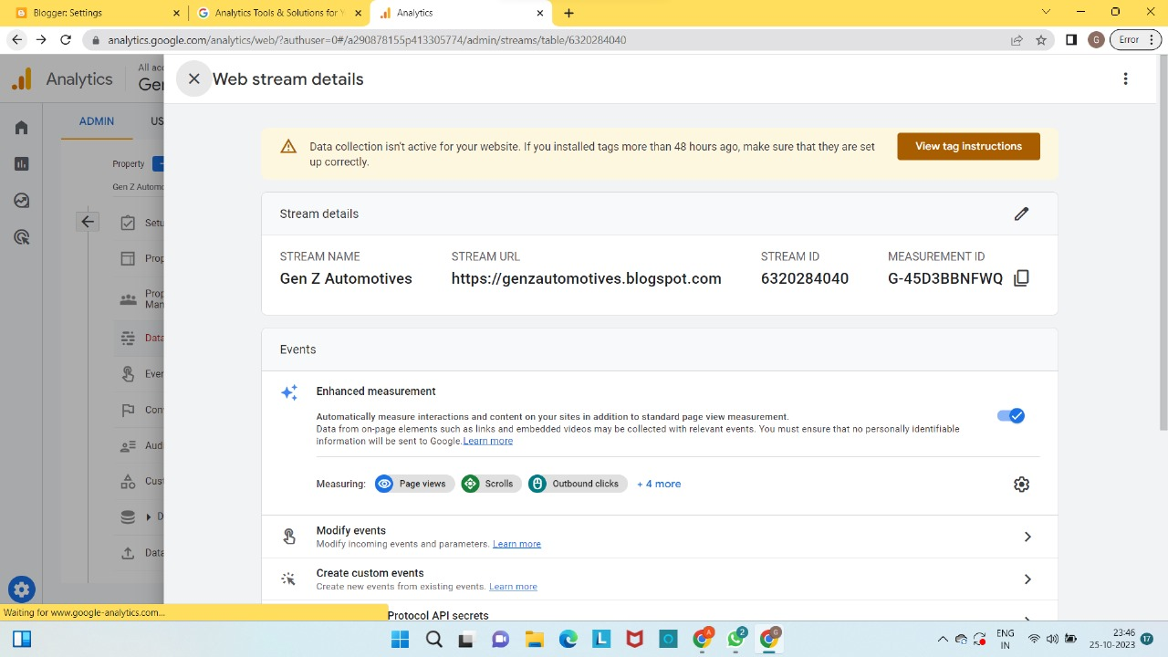

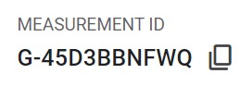

**Embedding the Google Analytics code in the blog –**

**STEP 1:**

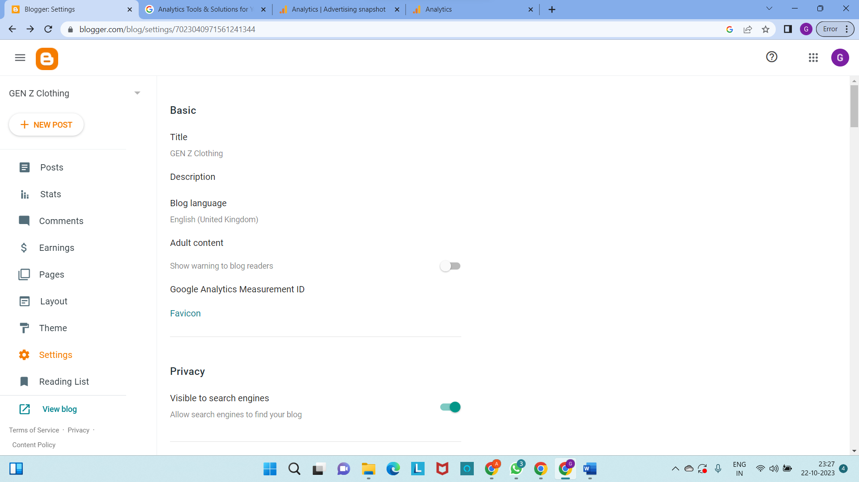

**STEP 2:**

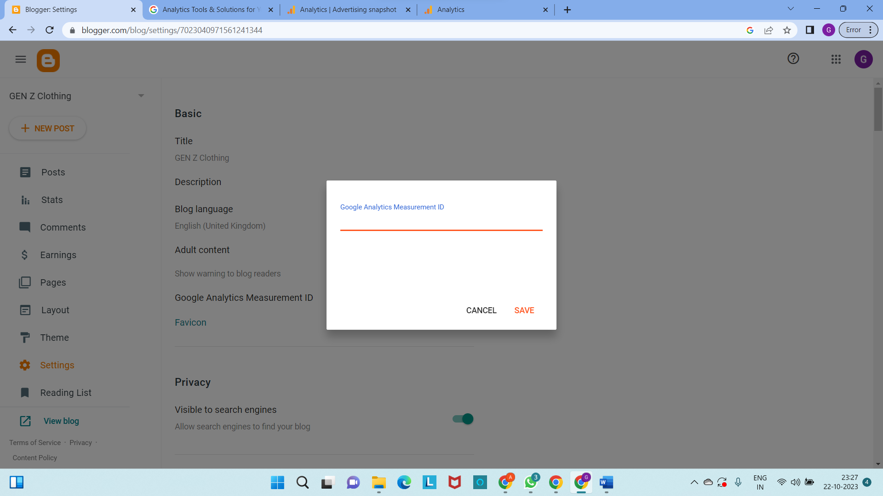

**STEP 3:**

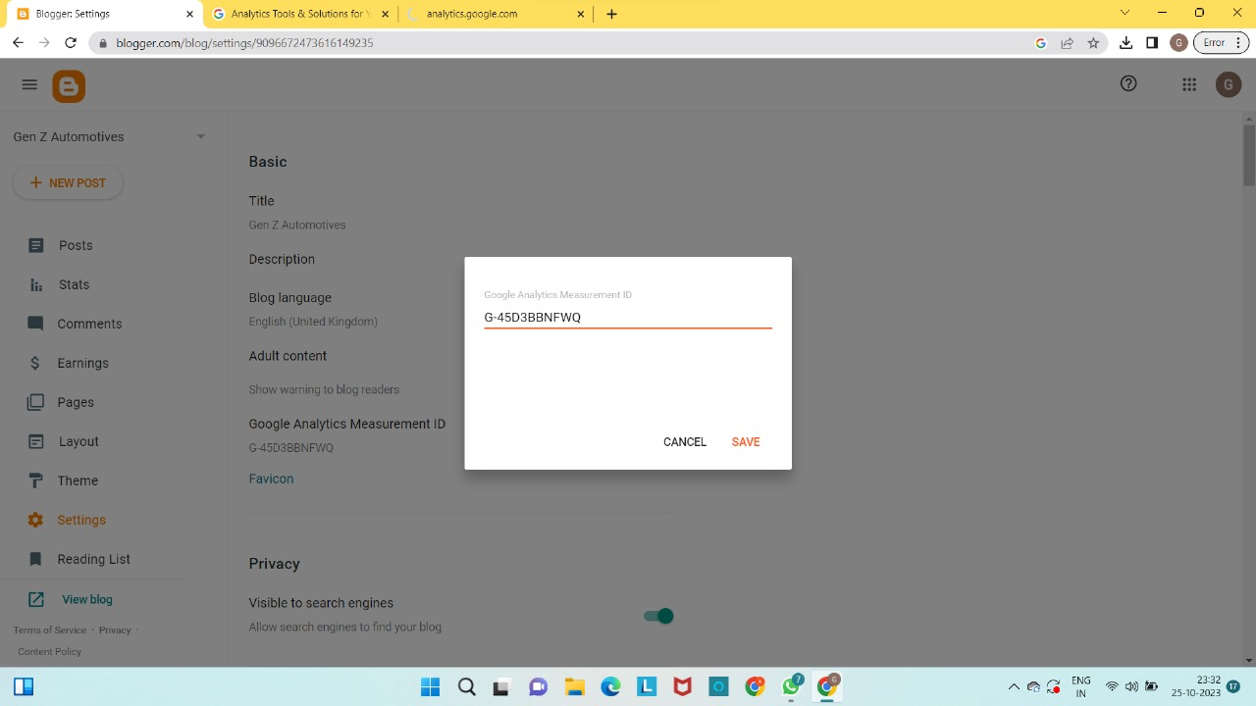

**RESULTS:**

Therefore, the google analytics code is embedded on the blog site successfully.

